Cascade training report
Working package 3.2 Cascade training for the sharing of EU experience

On June 15th, 2021 (Tuesday) we had cascade training for 22 staff, Academic officer workers, IT Engineers, Lecturers. We have discussed research activities at the Chemnitz University of Technology.

WP 3.2. PC teachers’ training abroad
Date: 19.04.2021-23.04.2021
Chemnitz University of Technology

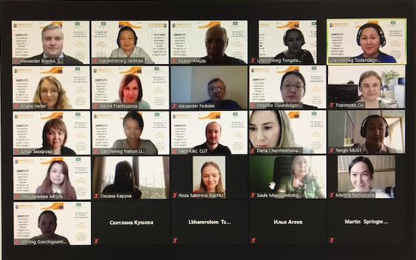

The date of the cascade training: 2021.06.15
The speakers: NARANTSETSEG Yadmaa, KHISHIGJARGAL Gonchigsumlaa
The target group: MUST level training.
The number of the participants: 22
The list of the participants:

