Student fairs Report

Working package 9.3 Student fairs in the PC universities

To help students and the young generation study at EU universities were introduced which are in this project European and Partner universities, including Riga Technical University, and the requirements for university admission and quality assurance system were explained. And Dr. Zorig.G, the leader of the Smart Ulaanbaatar project and member of the Project team of MUST, gave a presentation, answered questions from students, and discussed. In addition to the students of the Mongolian University of Science and Technology, the Student fair was attended by students from the Cloud Universities Consortium's members universities.

WP 9.3. Student fairs
Date: 23.08.2021-30.08.2021
Academic Affairs of Mongolian University of Science and Technology

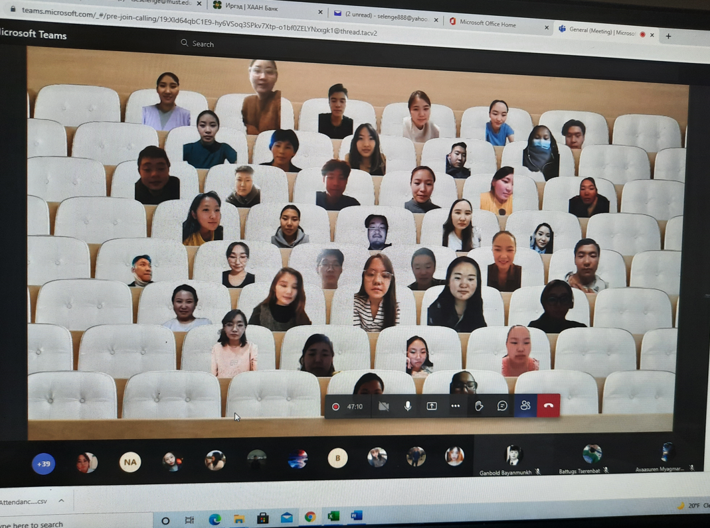

The speaker: BATDORJ Davaagombo, Head of Academic Affairs of MUST
The speaker: ZORIG Gungee, President of Cloud Universities Consortium
The speaker: NARANTSETSEG Yadmaa, Director of Graduate School of Engineering, MUST
From Presentation of Dr.Zorig.G: www.smartcity.edu.mn_Documents

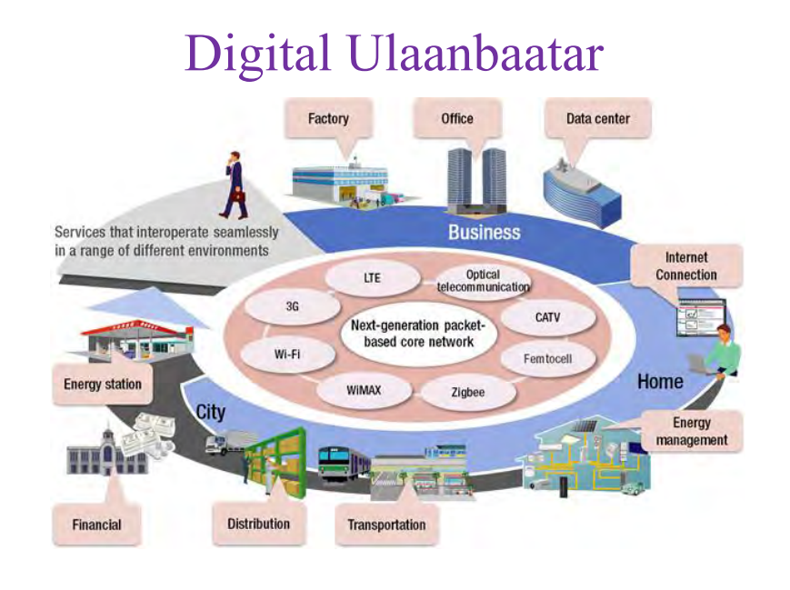
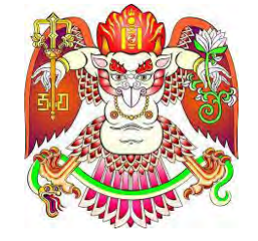

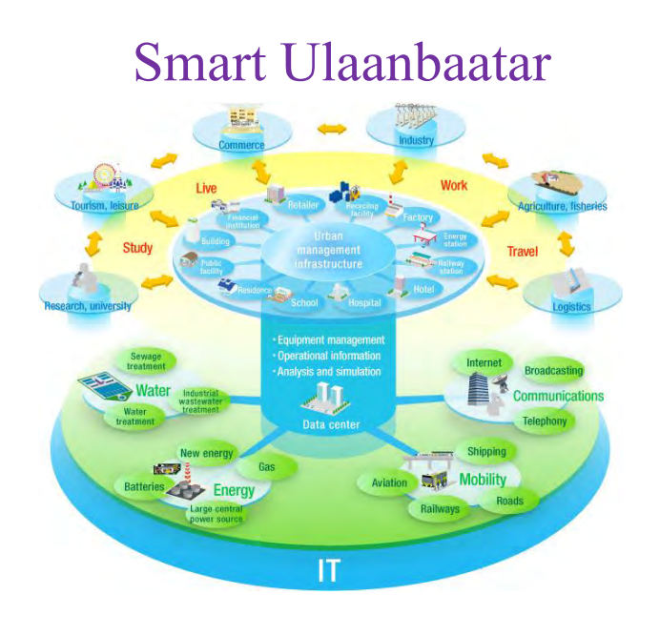
The Photos of the Participants:

